MASTER LIST OF CONTENTS FOR PHYSICS 566

NOTES:

- ODE’s
- ODE’s: SHO & Bessel’s Equation
- WKB
- WKB: through LRC cct example
- WKB: through Neumann series
- WKB: solution to Airy Equation
- WKB: connection formulas
- ∞ Series I: convergence; prelim. & comp. tests
- ∞ Series II: thru evaluation of series
- ∞ Series III: thru properties of power series
- ∞ Series IV: conv. in the mean, transf.
- SL Theory I: thru orthogonality
- SL Theory II: thru
- SL Theory III: Λ(u_{λ})>λ
- SL Theory IV: λ_{n}→∞. D_{n}→0
- Complex Variables I: thru Integral Theorem
- Complex Variables II: Laurent Theorem
- Complex Variables III: Residues
- Complex Variables IV: Contour Integration
- Complex Variables V: Contour integration & Real integrals
- Complex Variables VI: Branch Cuts
- Complex Variables VII: Gauss Sum
- Sp F I: Legendre Equation & Generating Functions
- Sp F II: Generating Functions & Legendre Equation
- Sp F III: Properties of the P_{n} & Q_{n}
- Sp F IV: Associative Legendre Functions. Spherical Harmonics
- Sp F V: Bessel Functions
- Sp F VI: Bessel→Hankel
- Sp F VII: HG equation
- Sp F VIII: Singularities & Riemann Equation
- Sp F IX: CHG function particulars
- Evaluation of Integrals: partial integration
- Evaluation of Integrals: thru Fresnel

PROBLEMS

- Analyze equations for a two-level (QM) system
- Solve 4 ODEs from M & W
- Solve: y”+ay’+by=f(x), a & b = constant, when roots μ₁=μ₂
- Examine linear dependence / independence of {f_{n}(x)} via Wronskian
- Convert y”+p(x)y’+q(x)y=0 to Ricatti’s Equation
- Solve 2 ODEs from M & W
- Find series solutions to hypergeometric equation
- Find a particular solution to: 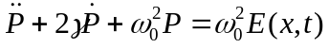
- Do Green’s function solution from for: p(x)y”+q(x)y’+r(x)y=0
- Solve: xy”+2y’+(ε-x)y=0, y(0)=1, y(∞)=0. What ε’s?
- Find energies of a QM SHO via Bohr-Sommerfeld Formula
- Find asymptotic form for J_{ν}(x) as x→∞, via WKB method
- Iterate u_{n+1}(s) Neumann series
- employ cct model Ω=ω₀e^{-αt}
- Solution to: y”+αξ^{n}y=0. Asymptotic form for y(ξ) as ξ→∞
- Prove two convergence tests
- Test * series for convergence & identify tests used
- Sum 3 series in closed form and find numerical values
- Sum 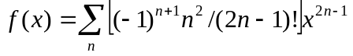 in closed form
- Stack books in Harmonic fashion
- D = f(d²/dx²) + g(d/dx) + h is self adjoint → f,g,h related
- Write hypergeometric ODE in Sturm- Liouville Formula
- Estimate lowest eigenvalue for u”+k²u=0 via functional Λ(u)
- For f(z)=u+iv analytic, fill in the blanks
- Prove Liouville’s Theorem: f(z) bounded for all z then f(z)=constant
- Prove Fundamental Theorem of Algebra: P_{n}(z)=0 has n roots
- Evaluate 3 integrals by means of contour integration
- Evaluation of Fresnel Integrals by contour integration of 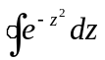
- Evaluation of 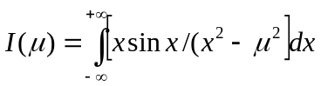 by contour integration
- Proof of Leibniz Theorem: (d/dx)^{n}[A(x)b(x)]=…. By math induction
- Gram-Schmidt orthogonalization procedure
- Apply G-S orthogonalization to {x_{n}} on |x|≤1 → get P_{n}(x)
- Generating function for fn’s obeying: (a)(n+1)F_{n+1} = xF_{n} - F_{n+2}, etc.
- Potential generated by a linear electric quadrupole
- Legendre → Parseval Theorem. σ_{tot} for partial wave analysis
- Legendre polynomial series from Laplace’s Integral
- m-reflection rule for associated Legendre polynomials
- on Rodrigues’ formula for P_{n}(x): (d/dx)n(x²)^{n-k} over [n/2]+1≤k≤n
- Evaluation of Gaussian integrals: 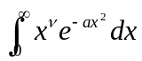
- For Bessel’s Equations, show J_{v} & Y_{v} are linearly independent
- Prove: J_{n}(x)=(-1)^{n}x^{n}(1/x d/dx)^{n} J₀(x) by mathematical induction
- For Bessel functions, analyze: 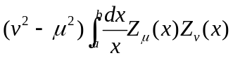
- Show F(a,b;c;x) & x^{1-c}F(1+a-c,1+b-c;2-c;x) are dept when c→N
- From a linear transformation on F(a,b;c;z), find M(a,c,x→∞)
- For the CHG equation, find Wronskian for M(a,c,x) & K^{1-c}M(1+a-c,2-c,x)

EXAMS

- Midterm

  - Equation of motion for a falling raindrop: evaporation + viscous drag
  - Convergence & summation of: S(x) = 1+ 3x² + 5x⁴ + 7x⁶ + …
  - Wronskian for: f(x)y” + g(x)y’ + h(x)y =0
  - Orthogonality of SL eigenfunction derivatives : 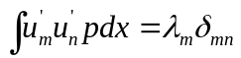
  - Reflection of a radio-wave by the ionosphere via WKB

- Final

  - Solve: (A) xy’ = αy + x^{β} , α & β=const. (B) y’ = xy +1
  - WKB solution to: y” + x²y = 0, near x = 10 with y=0 y’=1 @ x=10
  - Sum series to closed forms: (A) 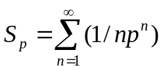, (B) 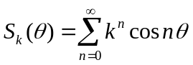
  - Rudimentary analysis of Laguerre’s ODE, using S-L Theory
  - Evaluate by contour integration: 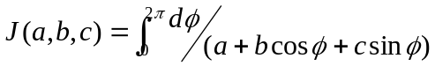
  - Legendre polynomials: show 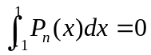 for n≥1
  - Show erfx α M(1/2,3/2,-x²). Find asymptotic erfx as x→∞
  - Evaluate two integrals, by series integration & parametric differentiation

